**INTRODUCTION TO COMPUTER HARDWARE**

Hardware represents the physical and tangible components of a computer, i.e. the components that can be seen and touched.

**Examples of Hardware are the following −**

* **Input devices** − keyboard, mouse, etc.
* **Output devices** − printer, monitor, etc.
* **Secondary storage devices** − Hard disk, CD, DVD, etc.
* **Internal components** − CPU, motherboard, RAM, etc.

**Central Processing Unit (CPU)**

It is the brain of the computer. It is the part that does most of the work in a computer system. Just like how our brain controls our body and processes information, the CPU carries out instructions from programs and performs calculations. It’s made up of smaller components that work together to execute tasks, making it the heart of any computing device.

**Components of a CPU**

* **Control Unit (CU)** – Directs the flow of data within the system.
* **Arithmetic Logic Unit (ALU)** – Performs arithmetic and logical operations.
* **Memory** – Can store instructions, data, and intermediate results.

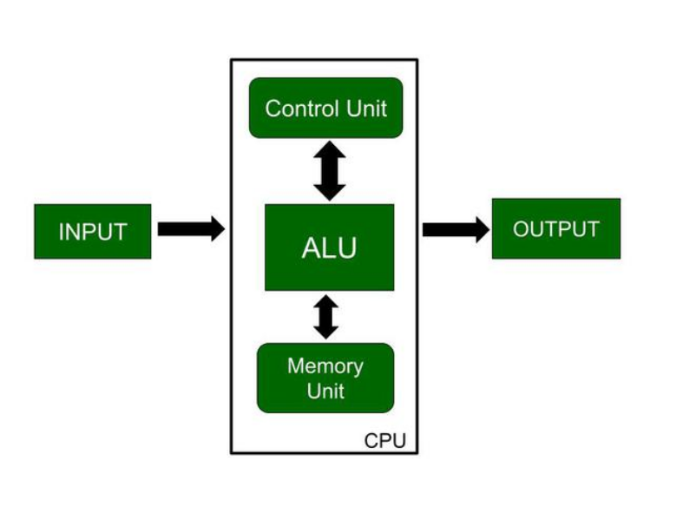

**Control Unit**

A control unit controls the operations of all parts of the computer but it does not carry out any data processing operations. Executing already stored instructions, It instructs the computer by using the electrical signals to instruct the computer system. It takes instructions from the memory unit and then decodes the instructions after that it executes those instructions. So, it controls the functioning of the computer. Its main task is to maintain the flow of information across the processor.

**The main functions of the control unit :**

* Controlling of data and transfer of data and instructions is done by the control unit among other parts of the computer.
* The control unit is responsible for managing all the units of the computer.
* The main task of the control unit is to obtain the instructions or data that is input from the memory unit, interpret them, and then direct the operation of the computer according to that.
* The control unit is responsible for communication with Input and output devices for the transfer of data or results from memory.
* The control unit is not responsible for the processing of data or storing data.

**ALU (Arithmetic Logic Unit)**

ALU (Arithmetic Logic Unit) is responsible for performing arithmetic and logical functions or operations. It performs two main operations:

* **Arithmetic Section:**By arithmetic operations, we mean operations like addition, subtraction, multiplication, and division, and all these operations and functions are performed by ALU. Also, all the complex operations are done by making repetitive use of the mentioned operations by ALU.
* **Logic Section:** By Logical operations, we mean operations or functions like selecting, comparing, matching, and merging the data, and all these are performed by ALU.

**Memory or Storage Unit**

As the name suggests this unit can store instructions, data, and intermediate results. The memory unit is responsible for transferring information to other units of the computer when needed.

Its size affects speed, power, and performance. There are two types of memory in the computer, which are **primary memory** and **secondary memory**.

Some main functions of memory units are listed below:

* Data and instructions are stored in memory units which are required for processing.
* It also stores the intermediate results of any calculation or task when they are in process.
* The final results of processing are stored in the memory units before these results are released to an output device for giving the output to the user.
* All sorts of inputs and outputs are transmitted through the memory unit.

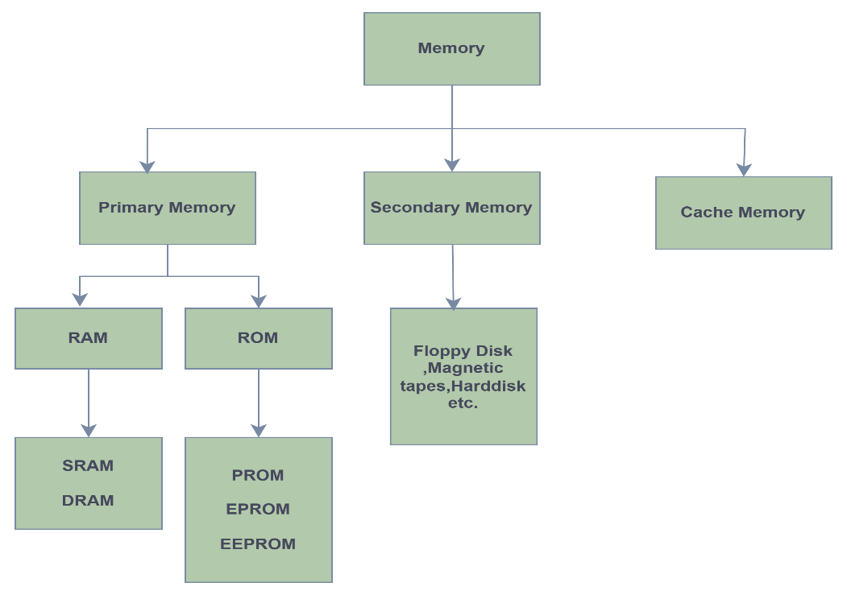

**Primary Memory**

Primary memory is a segment of computer memory that can be accessed directly by the processor. In a hierarchy of memory, primary memory has access time less than secondary memory and greater than cache memory. Generally, primary memory has a storage capacity lesser than secondary memory and greater than cache memory.

**Classification of Primary Memory**

Primary memory can be broadly classified into two parts:

* **R**andom **A**ccess **M**emory (RAM)
* **R**ead-**O**nly **M**emory (ROM)

**Random Access Memory (RAM)**

Any process in the system which needs to be executed is loaded in RAM which is processed by the CPU as per Instructions in the program.

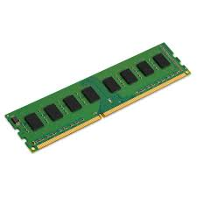

**Types of RAM:**

RAM can be broadly classified into SRAM (Static RAM) and DRAM (Dynamic RAM) based on their behaviour:

* **DRAM:**Dynamic RAM or DRAM needs to periodically refresh in a few milliseconds to retain data. DRAM is made up of capacitors and transistors and electric charge leaks from capacitors and DRAM needs to be charged periodically. DRAM is widely used in home PCs and servers as it is cheaper than SRAM.
* **SRAM:** Static RAM or SRAM keeps the data as long as power is supplied to the system. SRAM uses Sequential circuits like a flip-flop to store a bit and hence need not be periodically refreshed. SRAM is expensive and hence only used where speed is the utmost priority.

**Read-Only Memory (ROM)**

Any data which need not be altered are stored in ROM. It stores **firmware** (permanent software needed for basic computer operation).

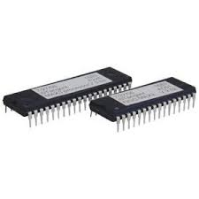

**Types of ROM:**

* **PROM:***Programmable ROM*can be modified once by the user. The user buys a blank PROM and writes the desired content but once written content cannot be altered.
* **EPROM:***Erasable and Programmable ROM*Content can be changed by erasing the initial content which can be done by exposing EPROM to UV radiation. This exposure to ultra-violet light dissipates the charge on ROM and content can be rewritten on it.
* **EEPROM:***Electrically Erasable and Programmable ROM*Content can be changed by erasing the initial content which could be easily erased electrically. However, one byte can be erased at a time instead of deleting in one go. Hence, reprogramming of EEPROM is a slow process.

**Secondary memory**

Secondary memory is a type of computer memory that is used to store data and programs that can be accessed or retrieved even after the computer is turned off. Unlike primary memory, which is volatile and temporary, secondary memory is non-volatile and can store data and programs for extended periods of time. Example:-Hard Disk, Floppy Disk, Magnetic tapes.

**Hard disk drives (HDD)**

**Hard disk drives (HDD)** serve as secondary storage, providing a non-volatile medium for data. It is a traditional storage device that uses spinning magnetic disks. Hard discs are used to install operating systems, programmes, and other storage devices, they are also used to save documents. HDD means the data is retained when our computer system is shut down. HDD is also called a fixed disk, hard disk, or hard drive.

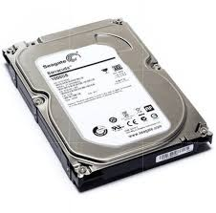

**HDD have below components:**

* **Platters:** Magnetic platters are disk-like in shape and used to store data. Typically, they are made from glass or aluminium and laid down on a spindle where layers of such disks are kept one after the other.
* **Spindle:** The spindle maintains the platters in place and rotates them as required. The Revolution Per Minute (RPM) rating controls how fast data can be written to and read from the hard drive.
* **Actuator Arm:** The actuator, also known as the head actuator, is a tiny motor that controls the movement of the read/write haed and monitors data transfer between the platters. It is in charge of ensuring that the read/write heads are always in the proper direction.
* **Read/write Head**: The read/write arm controls the movement of the read/write heads, that perform the actual reading and writing on the disc platters.

**Advantages of Hard Disk Drive (HDD)**

* One of the significant advantages of a Hard Disk drive is that its cost is low.
* Another advantage of Hard Disk Drive is that it is readily available in the market.
* Hard Disk Drives are faster than the optical disks.
* The capacity for storing the data in HDDs are large.

**Disadvantages of Hard Disk Drive (HDD)**

* The speed of reading and writing in HDD is slower than the RAM.
* HDDs are noisy.
* Another disadvantage of HDD is energy inefficiency.
* HDDs consume more power.
* The form factor of HDDs is heavier than the SSDs.

**Motherboard**

The motherboard is mounted inside the case and is securely attached via small screws through pre-drilled holes. Motherboard contains ports to connect all of the internal components. It provides a single socket for CPU, whereas for memory, normally one or more slots are available. Motherboards provide ports to attach the floppy drive, hard drive, and optical drives via ribbon cables. Motherboard carries fans and a special port designed for power supply.

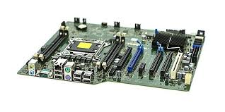

**Features of Motherboard**

A motherboard comes with following features –

* Motherboard varies greatly in supporting various types of components.
* Motherboard supports a single type of CPU and few types of memories.
* Video cards, hard disks, sound cards have to be compatible with the motherboard to function properly.
* Motherboards, cases, and power supplies must be compatible to work properly together.

**Daughter Cards**

Daughter cards, also known as daughterboards or expansion cards, are circuit boards that connect to the motherboard of a computer system. They are used to add functionality or enhance the capabilities of the computer.

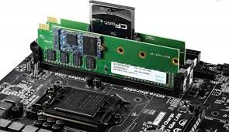

**Key Features of Daughter Cards**

* **Functionality**: Daughter cards can provide a wide range of functionalities, including **Graphics Processing**, **Sound Processing**, **Network Connectivity**, **Storage Controllers**, **Specialized Processing** etc.
* **Connection**: Daughter cards typically connect to the motherboard via expansion slots like **PCI (Peripheral Component Interconnect), PCIe (PCI Express)**, **AGP (Accelerated Graphics Port).**
* **Form Factor**: Daughter cards come in various sizes and shapes, depending on their intended use and the type of slot they are designed for.
* **Power Requirements**: Some daughter cards, especially high-performance graphics cards, require additional power connectors from the power supply unit (PSU) to function properly.

**Examples of Daughter Cards:-**

**Graphics Card (GPU)**: Enhances visual performance and rendering capabilities.

**Sound Card**: Improves audio quality and provides additional audio ports.

**Bus Slots**

Bus slots, also known as **expansion slots**, are connectors on a computer's motherboard that allow additional hardware components (daughter cards) to be installed. These slots facilitate communication between the motherboard and the installed components, enabling them to work together as part of the computer system.

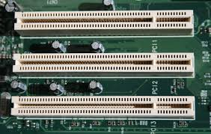

**Types of Bus Slots**

The different types of bus slots your PC might feature:

* **PCI Express:** The most advanced type of bus slot for your PC is the PCI Express, also referred to as PCIe. This type of slot is highly efficient and fast in communication with both the motherboard and the microprocessor.
* **PCI:**The most prevalent form of internal expansion for a PC is the PCI slot. Some PCs feature a combination of PCI and PCIe slots. In such cases, it's advisable to choose PCIe when available.
* **AGP:** This specific bus slot was created to handle graphics adapters, and its name, AGP, stands for Accelerated Graphics Port. While older PCs may have this slot, the latest video cards prefer the use of PCIe.
* **ISA:**The oldest type of bus slot is the ISA, which is known as Industry Standard Architecture. This slot is still in use because it's compatible with older bus cards.

**Switch Mode power Supply (SMPS)**

SMPS (Switch Mode Power Supply) is a modern DC regulated power supply used in computers and TVs. It includes a transformer, diode rectifier, and capacitor filter, which provide unregulated DC output. A transistor, acting as a switch, regulates the power.

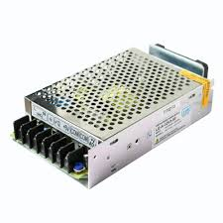

**Basic principle & Working**

* Input AC power is first rectified to DC using a diode bridge.
* This DC voltage is then chopped into high-frequency square waves by a switching transistor (like a MOSFET) controlled by a pulse width modulator (PWM).
* The chopped voltage is then applied to a transformer which steps up or down the voltage depending on the desired output.
* The transformer output is rectified and filtered to produce a smooth DC output.

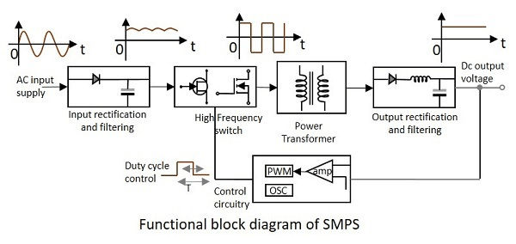

**Advantage of SMPS**

* Small in size and low-cost power supply.
* Low power dissipation results in less heating.
* Better regulation and efficiency.

**Disadvantage of SMPS**

* Since it uses a switching technique, it generates electromagnetic interference (EMI) like noise spikes, which may affect audio section of the main circuit.
* The control part of the circuit is expensive, complicated and less reliable.

**Interfacing Ports**

Interfacing ports are physical connectors on a computer or electronic device that allow for the connection of external peripherals and devices. These ports facilitate communication between the computer and external hardware, enabling data transfer, power supply, and control signals.

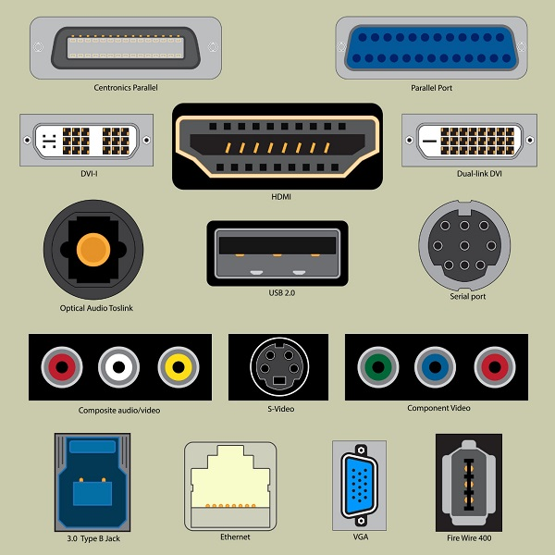

**Types of Computer Ports**

There are two types of computer ports discussed below:

* **Internal port** -Internal ports are used to connect internal devices like disk drives, CD drives, and other internal devices with the motherboard.
* **External port**-External ports are used to connect external devices modem, mouse, printer, flash drives, etc with the motherboard.

Let us now discuss a few important types of ports:

* **Serial Port:** A serial port is also called a communication port and they are used for connection of external devices like a modem, mouse, or keyboard (basically in older PCs).
* **Parallel Port:** Parallel ports are generally used for connecting scanners and printers. It can send several bits at the same time as it uses parallel communication.
* **USB Port:** It is used to connect all kinds of external USB devices, like external hard disk, printer, scanner, mouse, keyboard, etc.
* **PS/2 Port**: PS/2 ports are special ports used for connecting old computer keyboard and mouse.
* **VGA Port:** VGA ports also known as **Video Graphic Array** connectors are those which connect the monitor to a computer’s video card.
* **Sockets:** Microphones and speakers are connected with the help of Sockets to the sound card of the computer
* **Game Port:** These ports are used previously to connect a joystick to a PC. But nowadays it is replaced by USB ports.
* **Digital Video Interface (DVI) Port**
* **Ethernet Port:** Ethernet Port helps to connect to a network and high-speed Internet (provided by LAN or other sources). It connects the network cable to a computer and resides in an Ethernet card.